**OPEN ENDED LAB AND DESIGN PROBLEMS.**

**LAB REPORT # 09**



**Spring 2023**

**CSE103L Circuits & Systems-I Lab**

Submitted by: **Naveed Ahmad**

Registration No: **22pwcse2165**

Class Section: **B**

“On my honor, as student of University of Engineering and Technology, I have neither given nor received unauthorized assistance on this academic work.”

Student Signature: ______________

Submitted to:

**Dr. Muniba Ashfaq** May 27, 2023

Department of Computer Systems Engineering

University of Engineering and Technology, Peshawar

Mesh Current Analysis using

PSPICE

**Objectives Of Lab:**

* To construct resistive circuits and analyze the circuits using Mesh Analysis.
* To test and demonstrate the validity of mesh analysis through experimental measurements.
* Mesh analysis can be used to determine the current in a circuit.
* In this lab we also verify the mess analysis using PSPICE.

**Mesh Current Analysis:**

**Theory:**

Mesh analysis is a method that is used to solve planar circuits for the currents at any place in the electrical circuit. The mesh analysis technique will determine the currents of the circuit. Mesh analysis is based on KVL and is used to solve circuits by finding the unknown currents in each mesh.

**Meshes:**

A mesh is a barrier made of connected strands of  [metal](https://en.wikipedia.org/wiki/Metal), [fiber](https://en.wikipedia.org/wiki/Fiber), or other flexible or ductile materials.

**Circuit diagram:**

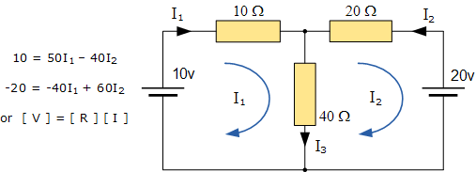

PSPICE Simulator:

**PSPICE** is a computer-aided simulation program that enables you to design a circuit and then simulate the design on a computer.

* **PSPICE** is largely popular because of its user-friendly interface.
* Support modeling of digital circuits, and its no-cost basic version.

**Procedure:**

**Finding Mesh Voltage Manually:**

* Assign a name to each mesh current like i1, i2, and i3.
* [Apply KVL to each mesh](https://electric-shocks.com/kirchhoffs-voltage-law-kvl/) and use [ohm’s law to express the voltage drop](https://electric-shocks.com/state-and-explain-ohms-law/) in each circuit element.
* There is n number of simultaneous equations, where n is a number of meshes.
* Use any method to solve these simultaneous equations for n mesh current.

**Finding Mesh Voltage Using pspice:**

* Open schematic program of PSpice
* Click on the “Get New Part” button on the toolbar
* Type ‘r’ in the search bar and place the eight resistors on the white sheet
* Type ‘vdc’ in the search bar and place two of them on the white sheet
* Type ‘gnd-earth’ and place it on the white sheet
* Now arrange these components on the white sheet according to the circuit diagram.

**Observations And Calculations:**

**Mathematical Calculations:**

**Mesh 1:** (1 + 1) i1 + 3 (i1 – i2) + 3 (i1 – i4) = 0

**Mesh 2**: 3 (i2 – i1) + (9 + 3) i2 + 1(i2 – i3) = 0

**Mesh 3:** 15 + 9 i3 + 2 (i3 – i4) + 1 (i3– i2) = 0

**Mesh 4: -**10 +3 (i4– i1) + 2 (i4– i3) + 6 i4 = 0

Solving these two equations we get :

i1 = 287.9229 mA, i2 = 16.057 mA

i3 = 1.1206 A, i4 = 783. 8524 mA

**Verification by PSPICE:**

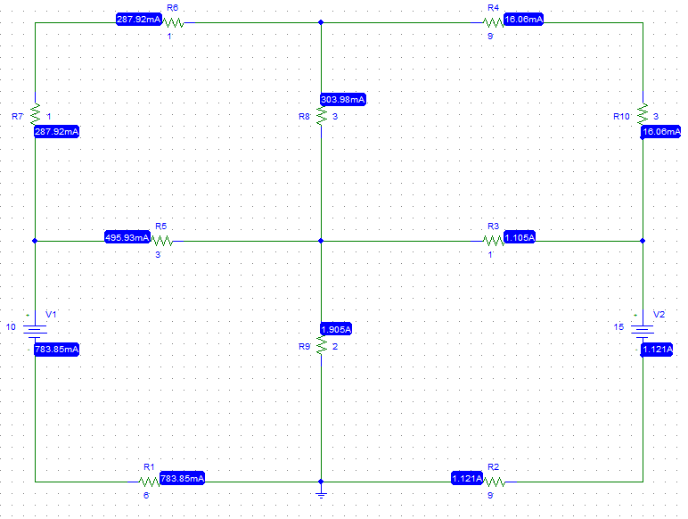

(From above figure.)

i1 = 287.92 mA, i2 = 16.06 mA

i3 = 1.121 A, i4 = 783. 85 mA

**Conclusion:**

*In this lab we use Mesh analysis to determine the current in a circuit and also verify the mess analysis using PSPICE. From both methods we get the same results.*

# LAB RUBRICS: (Circuits & Systems-I Lab)

|  |  |  |  |  |
| --- | --- | --- | --- | --- |
| **Criteria & Point Assigned** | **Outstanding 4** | **Acceptable 3** | **Considerable 2** | **Below Expectations 1** |
| **Attendance and**  **Attentiveness in**  **Lab**    PLO10 | Attended in proper Time and attentive in Lab | Attended in proper Time but not attentive in Lab | Attended late but attentive in  Lab | Attended late not attentive in Lab |
| **Equipment /**  **Instruments**  **Selection and**  **Operation**    PLO1,  PLO2,  PLO3,  PLO5, | Right selection and operation of appropriate equipment and instruments to perform experiment. | Right selection of appropriate equipment and instruments to perform experiment but with minor issues in operation | Needs guidance for right selection of appropriate equipment and instruments to perform experiment and  to overcome errors in operation | Cannot appropriately select and operate equipment and instruments to perform experiment. |
| **Result or Output/ Completion of**  **target in Lab**  PLO9, | 100% target has been completed  and well  Formatted. | 75% target has been  Completed and well formatted. | 50% target has Been completed but not well formatted. | None of the outputs are correct |
| **Overall,**  **Knowledge**  PLO10, | Demonstrates excellent knowledge of lab | Demonstrates good  knowledge of lab | Has partial idea about the Lab and procedure followed | Has poor idea about the Lab and procedure followed |
| **Attention to Lab**  **Report**  PLO4, | Submission of Lab  Report in Proper Time i.e. in next day of lab., with proper  Documentation. | Submission of Lab Report in proper time but not with proper  Documentation. | Late Submission with proper  Documentation. | Late Submission Very poor documentation |